Machine Learning Classification Algorithm:

Please find the below findings and the best model to predict the insurance charges.

- Problem Statement:

Stage 1: Domain- We are going to predict Chronic Kidney Disease that is numeric, so it is Machine Learning Classification.
Stage 2: Learning- Requirements are clear with both inputs and output so it will come under Supervised Learning.
Stage 3: Department- Chronic Kidney Disease outputs are categorical so the department is Classification.

- Dataset Info

Total no of Rows: 399
Total no of Columns: 25

- Preprocessing Data
We are using nominal data conversion for the all the column where those inputs are having string values include output column “Classification”.

- Models used to predict Insurance charges:

Logistic Regression
Support Vector Machine
Decision Tree
Random Forest

- Models research values

Logistic Regression:

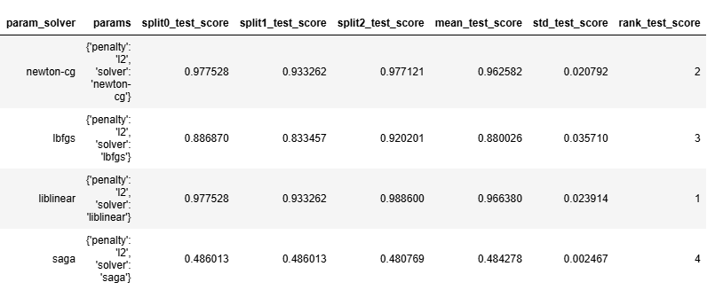

Decision Tree:

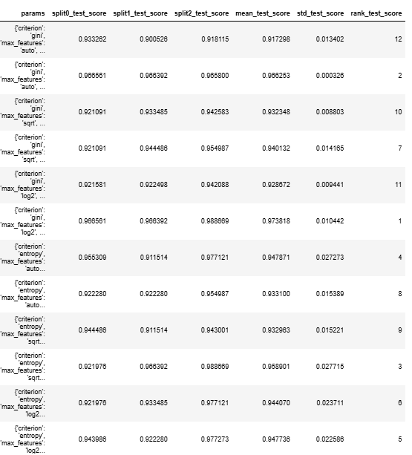

Random Forest:

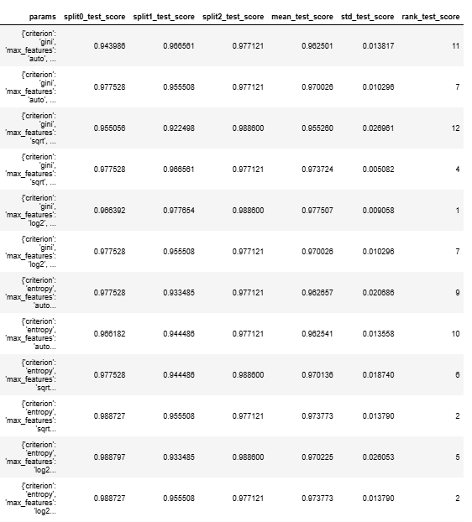

Support Vector Machine:

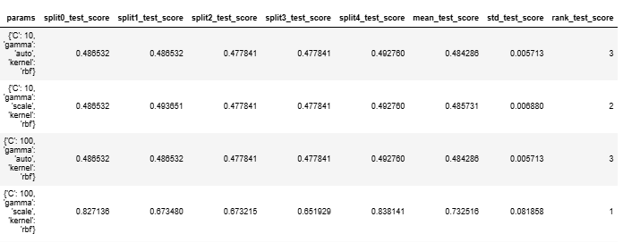

The best model among the above models is Decision Tree('criterion': 'gini', 'max_features': 'log2', 'splitter': 'random'), because the value is near to 1.
Please find all the ipynb in the below link
https://github.com/veenakani/Classification-Assignment

